* Created folder in D drive with name data_engineering. And opened that folder in visual studio code by clicking open as code.
* Login to github and create one repository named as data_engineering. And copy the repository link which is with extension .git <https://github.com/TIRUMALA9999/data_engineering.git>
* Check whether the python is installed in your system or not using “python - -version” in command prompt in vs code. If exist it shows the version number. If don’t shows install it and add it to the environment variables.
* Using conda command create a virtual environment and the required python version needed for your project **“conda create -p myenv python=3.12”.**
* Activate the environment using the command **“conda activate D:\data_engineering\myenv”**
* After activating you will see like this which shows you are in virtual environment.
* Now link this folder to the github repository created.
* 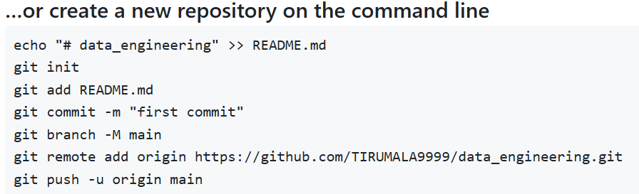
* Create **“.gitignore”** files to ignore the files that are not tracked by the git
* And write the file names like this in that folder **myenv/**